MACH4METAL

metalworking machinery
Transito 21,
6909 DA BABBERICH, Netherlands
Tel. + 31 (0)316 – 247123
Fax. + 31 (0)316 - 247956
info@mach4metal.com
www.mach4metal.com

Bank No : 66.52.13.883
IBAN : NL33 INGB 0665 2138 83
BIC : INGBNL2A

Automatic Bandsaw KASTO TWIN A4
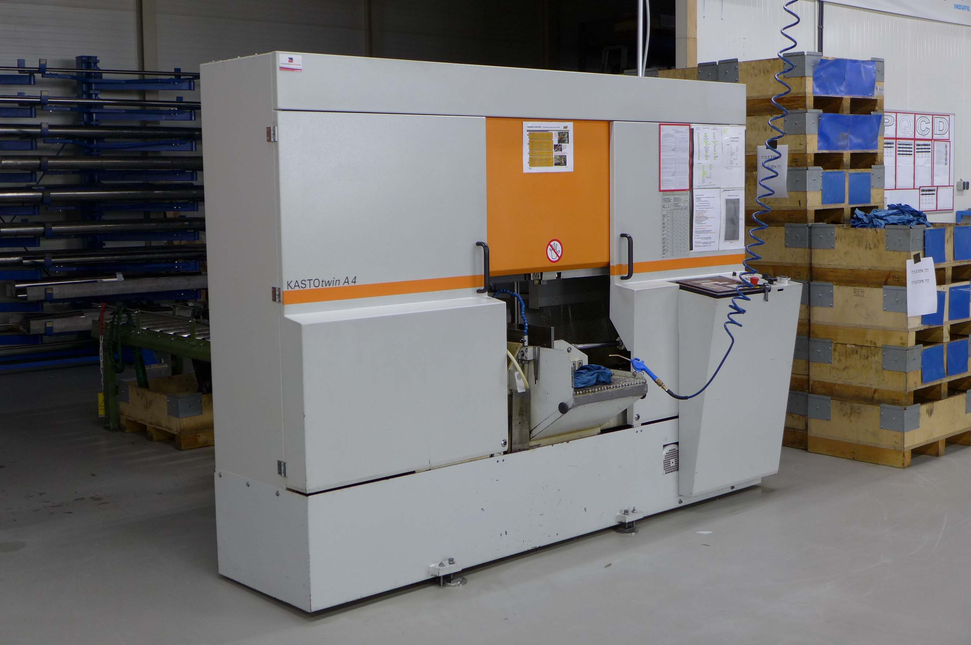

- Make : KASTO Germany
- Typ : TWIN A4
- No :
- Age : 2006

- Cutting Ø : 400
- Cutting flat : 400 x 400

- Feed single stroke : 750
- Feed multiple stroke : 9999
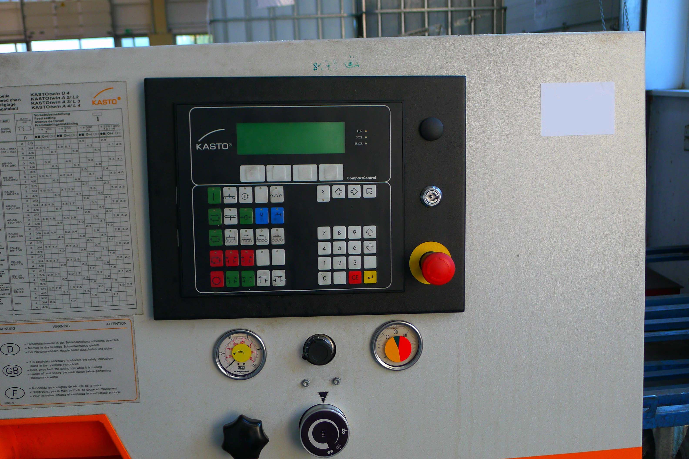
- Min. cutting length : 6
- Min. sawing Ø : 10

- Cutting Vario : 20 – 110 M/Min
- Saw band size : 5700 x 41 x 1.3

- Dimensions
- Length : 2.980
- Width : 2.700
- Height : 2.200
- Weight : 2.500
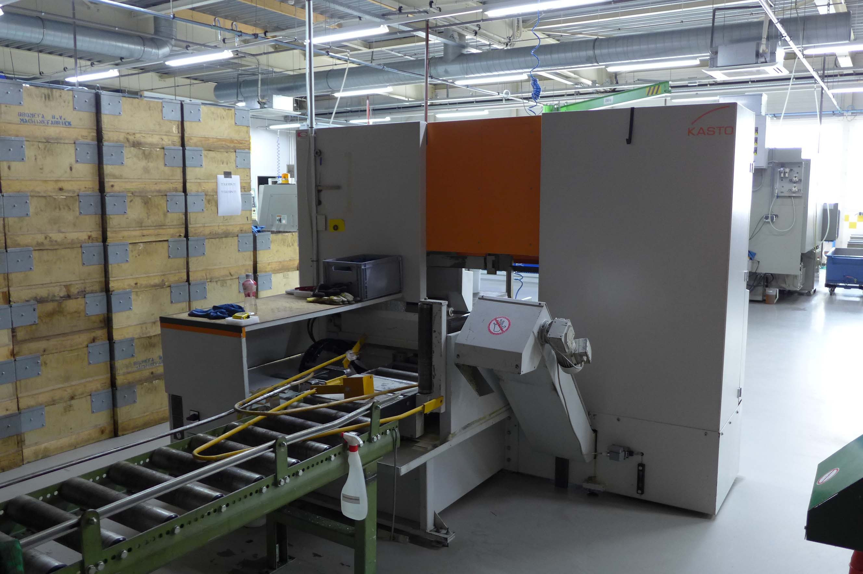
- Table height : 700
- Power : 7 kW

- Roller conveyor :??
- Up to 30 programs
- Compact Control
(Siemens S5 compatible)
- New EUR 40.000

Please Note: The above information has been obtained to the best of our ability and belief from, and from the manufacturers where possible. It is given in good faith, but its accuracy can not be guaranteed. Accordingly, it will not form a representation or constitute contractual terms. We advise you to check any vital details!

